

**GAP ANALYSIS DOCUMENT (GAD) SIGN-OFF**

**Authorization Memorandum**

This form is to sign-off completion of the Requirement Phase for **CAMPUS MANAGEMENT SOFTWARE AT WORLD SKILL CENTER (WSC).**

World Skill Centre (WSC) acknowledges receipt of the deliverables as part of the Requirement Phase through the submission of this document.

|  |  |
| --- | --- |
| **MODULE NAME** | **Academics Module** |

| **VERSION HISTORY** | | | |
| --- | --- | --- | --- |
| **Version** | **Author** | **Date** | **Changes** |
|  |  |  |  |
|  |  |  |  |

**WSC AUTHORITY NAME AND**  **SIGNATURE**

**SOUL AUTHORITY NAME AND**  **SIGNATURE**

Pages 1 of 10





**GAP Analysis Document**

Of

**Academics module**

For Implementation of

**Campus Management Software**

at

**World Skill Center (WSC)**

**Department - Admission / SOE / SOS**



**Sustainable Outreach And Universal**

**Leadership (SOUL) Limited**

**Contents**

A. Introduction 3

B. Overview of the Document 3

C. List of Screen 4

D. Academics 5

Existing Student Academics Flowchart 5

WSC Student Academics Flowchart 5

1. Groups & Schedules 6

1.1 Student Group 6

2. Attendance & Leave Application 6

2.1 Student Attendance 6

2.2 Student Attendance Tool 6

2.3 Student Leave Application 7

3. Mentor Mentee 7

3.1 Mentor Allocation 7

3.2 Mentor Mentee Communication 8

4. Course Schedule 8

4.1 Course Scheduling Tool 8

4.2 Course Schedule 9

# **Introduction**

The World Skill Center (WSC) is a premier advanced skill training institute established by the Government of Odisha, Skill Development and Technical Education Department, through the Odisha Skill Development Authority (OSDA). The WSC will impart advanced skill training in eight trades from engineering and service sectors. WSC caters primarily to induct the best talent from ITIs and Polytechnics and train them to become globally employable in emerging areas such as "Industry 4.0". WSC is housed in a state-of-the-art, 18-storey, air-conditioned building with nearly half a million square feet of space in the heart of capital city of Bhubaneswar.

With the Implementation of campus management software for WSC the goal is to streamline the operations and functions of the campus by integrating various processes, such as admissions, course registration, academic progress tracking, and financial management, HRMS, Procurement and Inventory management, etc into a unified system. The implementation also aims at providing a user-friendly interface for all stakeholders, making it easier for them to access the necessary information and complete their tasks with ease. The modules to be covered during the implementation of the software includes:

|  |  |
| --- | --- |
| Students Management Modules | Infrastructure Management |
| Academic System | Finance and Accounting System |
| Procurement & Inventory Management | Training and Placement |
| Human Resources Management System | Application Integration |

# **Overview of the Document**

The Gap analysis document is a detailed report that provides an overview of the

gaps between the current state of the project and the desired state, and develop recommendations to close those gaps. Conducting a gap analysis can help us to improve our product and profitability by allowing us to pinpoint “gaps” present in our software. Once it’s complete, we will be able to better focus on our resources and energy on those identified areas in order to improve them.

This document covers all the gaps between the existing software and functional requirements provided by WSC SME’s for Hostel module.

# **List of Screen**

The table below is list of screens present for the Academics module. Yes in Change in Existing column means that there will be change for a existing screen in the Campus management software, while Is new screen means the screen is not present in the existing software and will be newly developed. This document contains list of changes in existing screens, while requirements for new screens are covered in the SRS document.

|  |  |  |  |
| --- | --- | --- | --- |
| **SL no** | **Name of the Screens** | **Changes in Existing** | **Is New Screen ?** |
|  | Student Group | Yes | No |
|  | Course Scheduling Tool | Yes | No |
|  | Course Schedule | Yes | No |
|  | Student Attendance Tool | Yes | No |
|  | Student Attendance | Yes | No |
|  | Student Leave Application | Yes | No |
|  | Mentor Allocation | Yes | No |
|  | Mentor Communication | Yes | No |
|  | Mentee Communication | No | Yes |
|  | Assignment Given | No | Yes |
|  | Assignment Upload | No | Yes |

# **Academics**

# Existing Student Academics Flowchart

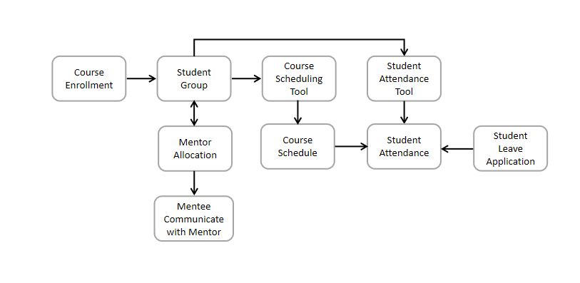

# acWSC Student Academics Flowchart

## **Groups & Schedules**

### **Student Group**

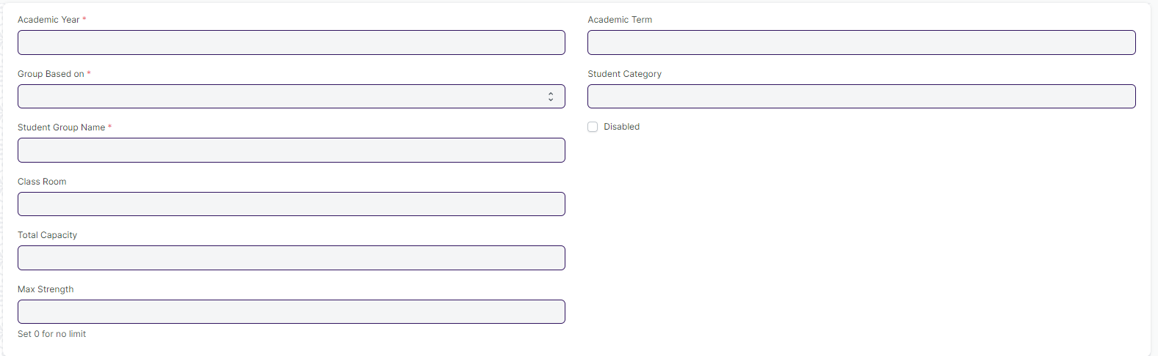

#### **Description of Changes:**

* Need to remove the Student Group based on Combined Courses and their respective fields such as Multiple Programs Table
* Programs and course name need to be rename to Course and Module.

## **Attendance & Leave Application**

### **Student Attendance**

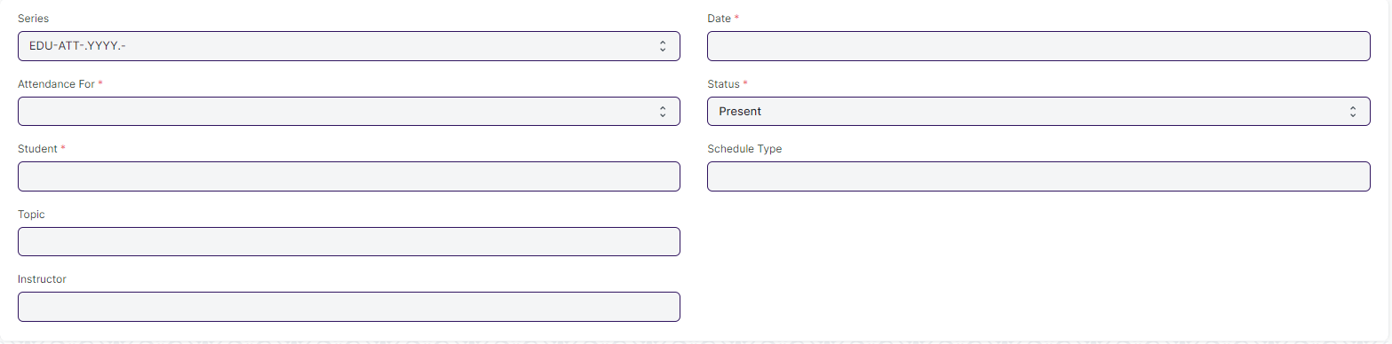

#### **Description of Changes:**

* In **Student Attendance** Screen Students attendance must be provided by an instructor before a specific deadline.

### **Student Attendance Tool**



#### **Description of Changes:**

* In **Student Attendance** Screen Students attendance must be provided by an instructor before a specific deadline.

### **Student Leave Application**

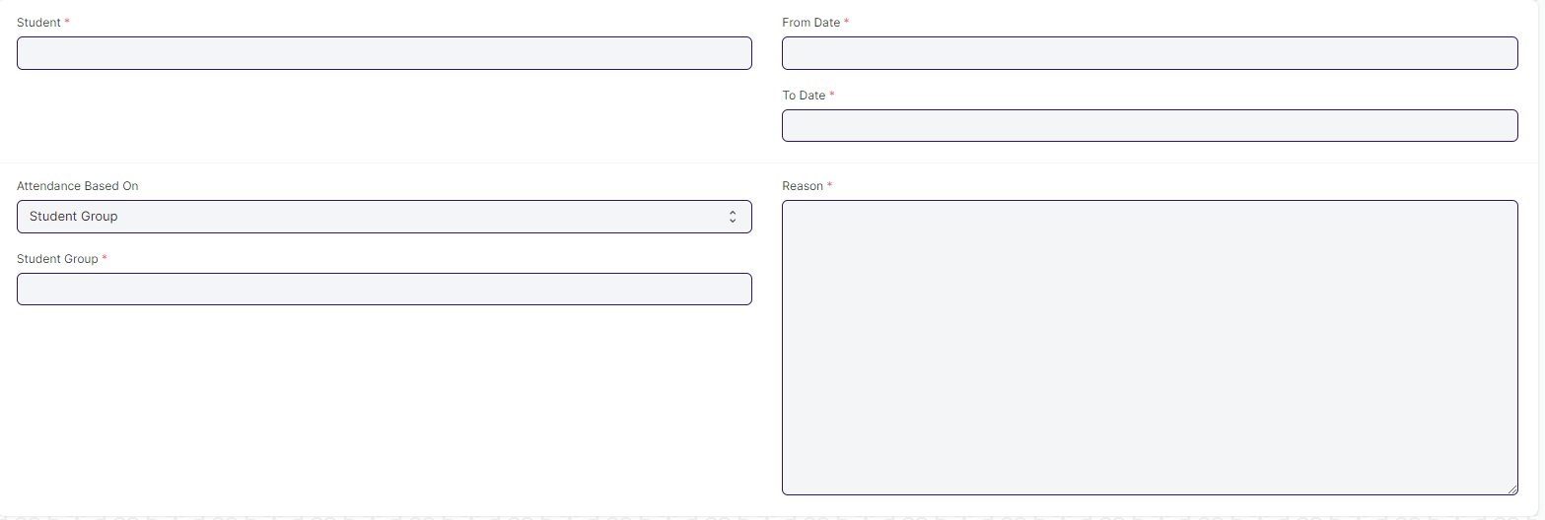

#### **Description of Changes:**

* A workflow needs to be added to the **Student Leave Application** screen where Class Advisor Role having the authority to approve the students leave Application.
* Workflow Actions: (Mail need to be triggered in every actions)

1. Approve
2. Reject
3. On hold

* Single Screen for Student Leave Application form
* Need to merge the two leave application form which are present in hostel and academic in to a single screen.

## **Mentor Mentee**

### **Mentor Allocation**

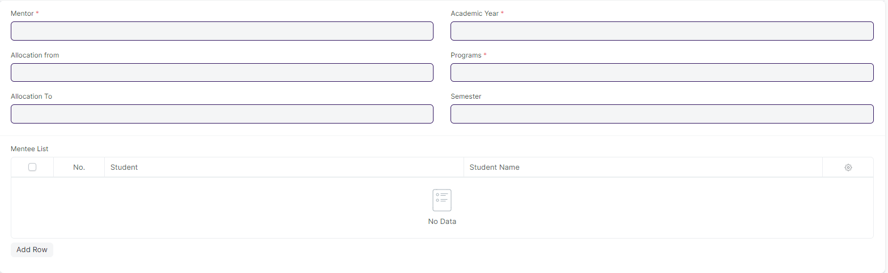

#### **Description of Changes:**

* Programs name need to be changed to Course.

### **Mentor Mentee Communication**

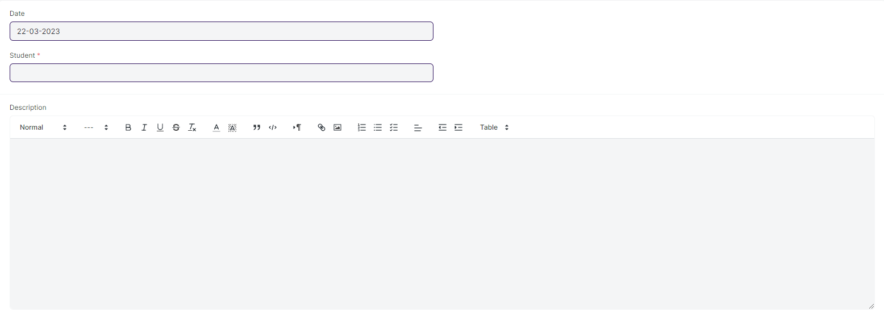

#### **Description of Changes:**

* In the **Mentor Mentee Communication** Screen, where mentors can message their students and a reply feature should be added so that mentors can respond to their respective mentees. (Notification need to be triggered to their respective mentees regarding the information given by the Instructor)

## **Course Schedule**

### **Course Scheduling Tool**

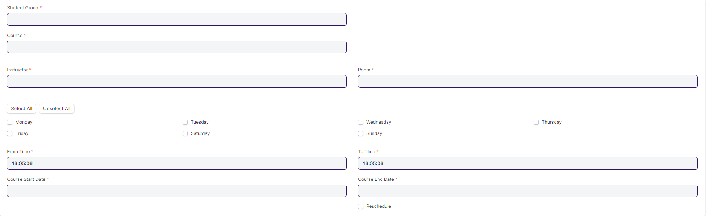

#### **Description of Changes:**

* Need to change the name of Course and Instructor to Module and Trainer.

### **Course Schedule**

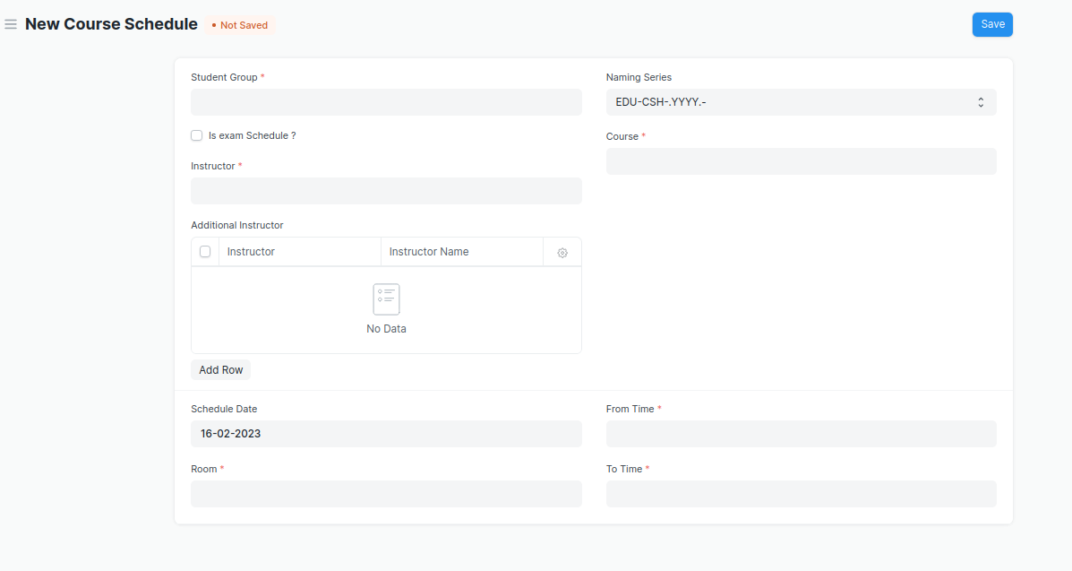

#### **Description of Changes:**

* Need to change the name of Course and Instructor to Module and Trainer.